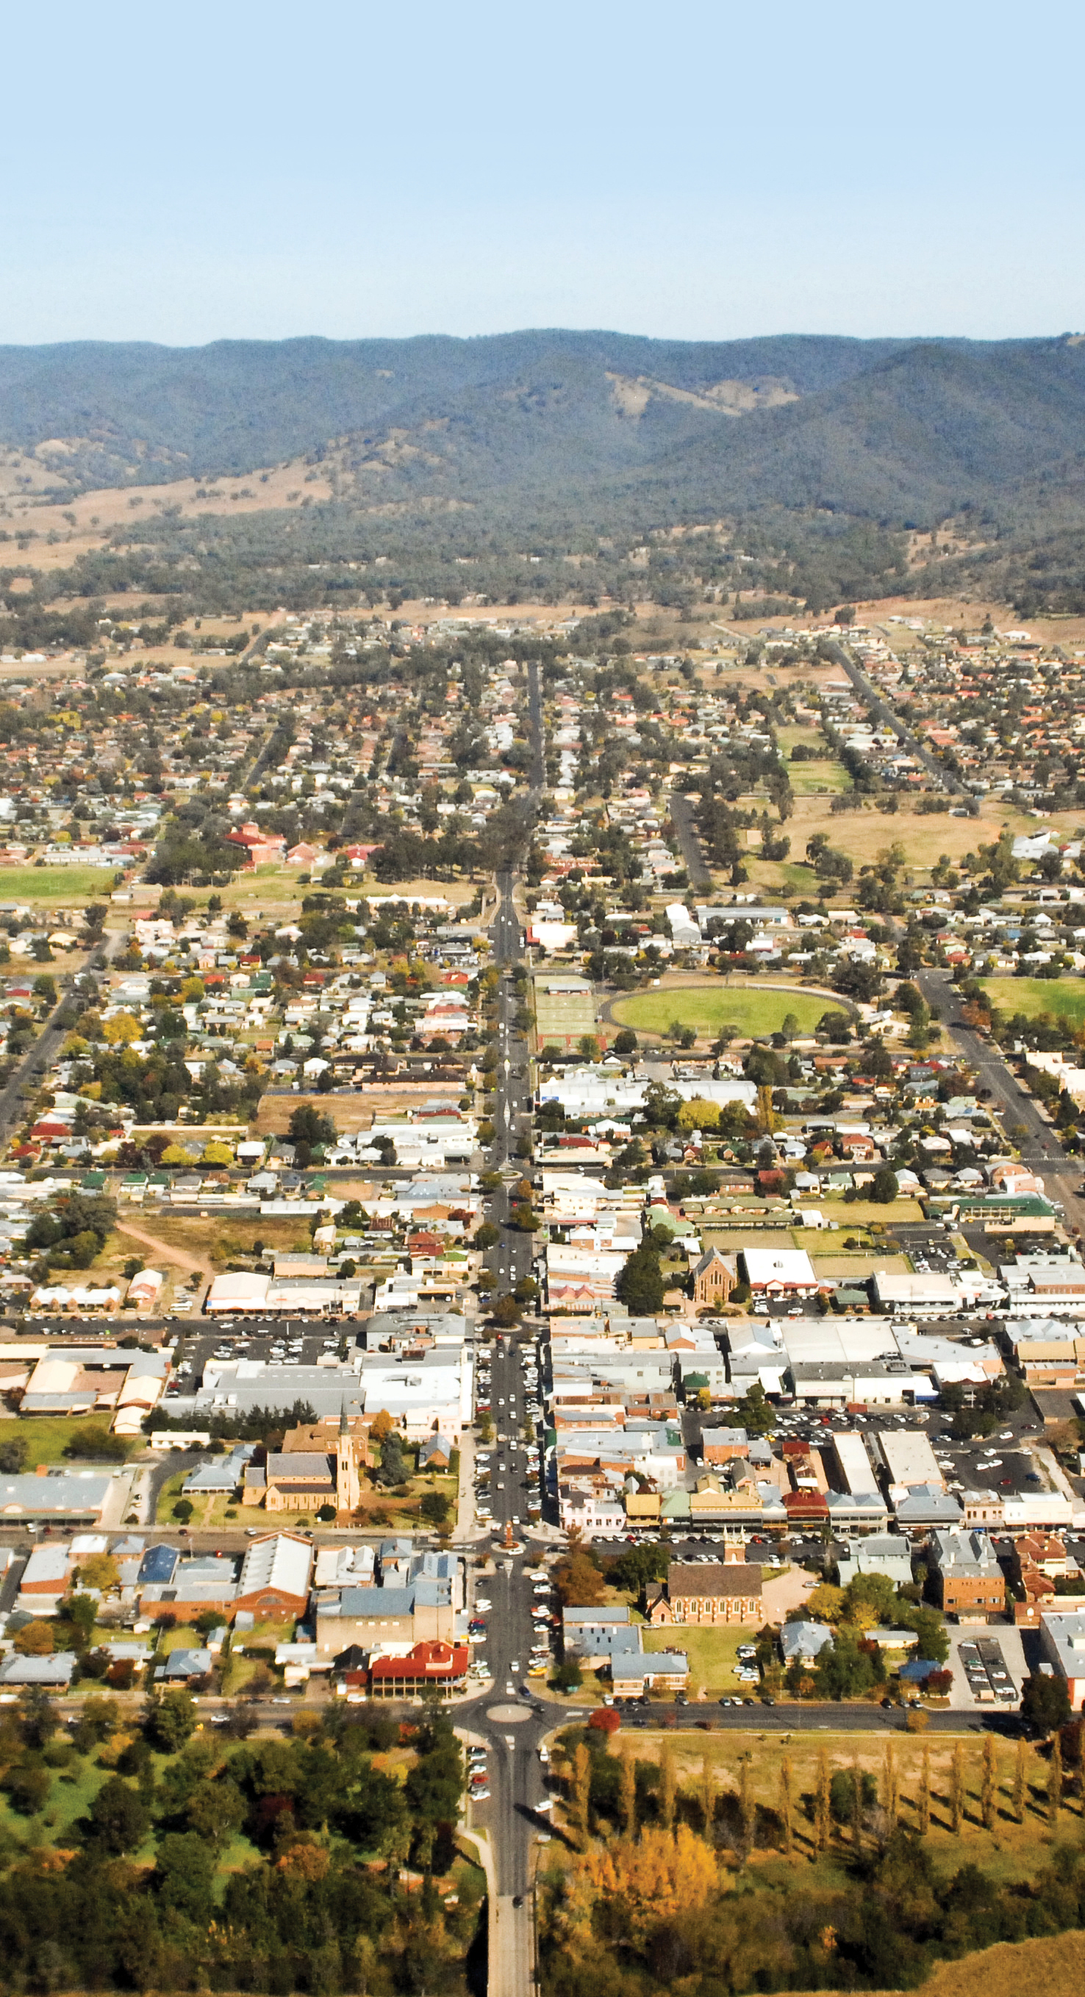 | planning proposal amendment  10 -12 Burrundulla Ave, Mudgee  2 April 2024
MID-WESTERN REGIONAL COUNCIL
Strategic Planning

Version | Date | Notes
V001 | April 2024 | PP reported to Council – April 2024

Table of Contents

Overview 4
Introduction 4
Background 4
Part 1 – Objectives or Intended Outcome 6
Objectives 6
Intended Outcomes 6
Land to which the Planning Proposal applies 6
Site context and setting 10
Part 2 – Explanation of Provisions 11
Part 3 – Justification 13
Section A - Need for the Planning Proposal 13
Section B - Relationship to Strategic Framework 14
Section C - Environmental, Social and Economic Impact 18
Part 4 – Mapping 20
Part 5 – Community Consultation 21
Part 6 – Project Timeline 22
Proposed Timeline 22

Overview

Introduction
The Planning Proposal seeks to amend Mid-Western Regional Local Environmental Plan 2012 (MWRLEP 2012) to rezone part of 10 - 12 Burrundulla Avenue, Mudgee (Lot 122 DP1074283) from RE2 Private Recreation to R3 Medium Density Residential. The Planning Proposal explains the intent of, and justification for, the proposed amendments to MWRLEP 2012.
The Planning Proposal is to implement the following changes to the MWRLEP 2012:
- Amend the Land Zoning Map (LZN_006G) from RE2 Private Recreation to R3 Medium Density Residential.
- Amend the Height of Buildings (HOB_6G) from no control to 8.5m.
- Amend the Lot Size Map (LSZ_06G) from no control to 600m².
The proposal has both strategic and site-specific merit.
The proposal has been prepared in accordance with Section 3.32 and 3.33 of the Environmental Planning and Assessment Act 1979 (the Act) and the relevant Department of Planning and Environment (Department), Local Environmental Plan Making Guideline, August 2023.

Background
MWRLEP 2012 came into effect on 10 August 2012. MWRLEP 2012 is the consolidation of the previous planning controls into one local environmental plan. It is also a translation of those controls into the NSW Government’s Standard Instrument Principal Local Environmental Plan.
The majority of the site is zoned RE2 Private Recreation, with the access handle to George Street zoned R3 Medium Density Residential. Figure 1 below details the existing zoning.
The site was formerly a bowling club.

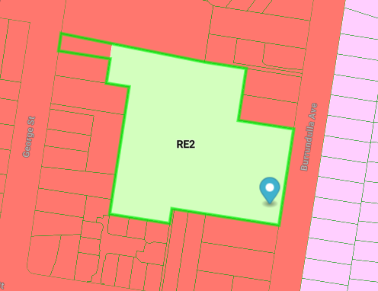
Figure 1: Existing zoning (subject site edged green (Source: Mecone Mosaic)

Part 1 – Objectives or Intended Outcome

Objectives
The objective of the Planning Proposal is to rezone part of the former bowling club from RE2 Private Recreation to R3 Medium Density Residential, to provide additional residential dwellings in the form of multi-dwelling housing to meet the rising demand for housing in the area and offer a diverse and more affordable housing form.

Intended Outcomes
The intended outcomes of the Planning Proposal are to:
- Permit infill multi-dwelling housing close to Mudgee CBD,
- Utilise existing social facilities and infrastructure,
- rezone part of the site from RE2 Private Recreation to R3 Medium Density Residential, and
- amend the relevant Mid-Western Regional Local Environmental Plan 2012 mapping to reflect surrounding development, including: zoning; height of building and minimum lot size.

Land to which the Planning Proposal applies
The land to which the planning proposal applies (subject site) is highlighted light blue and detailed in Figure 1 below. Figure 2 provides an aerial photograph of the site and its surrounds.
The subject site is 16648m² or 1.67ha and is bound by Burrundulla Avenue to the east, residential land zoned R3 – Medium Density Residential to the north and south and an access handle leading on to George Street to the west.
Access to the site is gained from both George Street to the west and Burrundulla Avenue in the east.

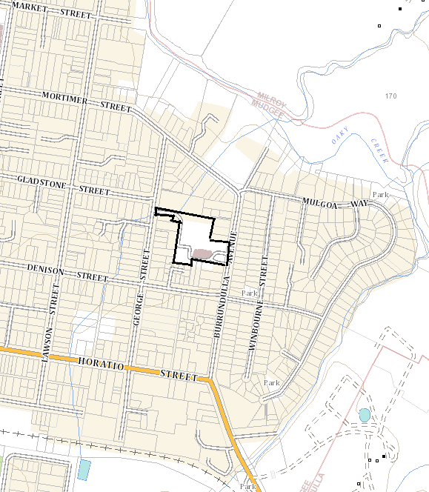
Figure 1: Planning Proposal subject area – outlined in black (Source: adapted from the NSW Planning Portal)

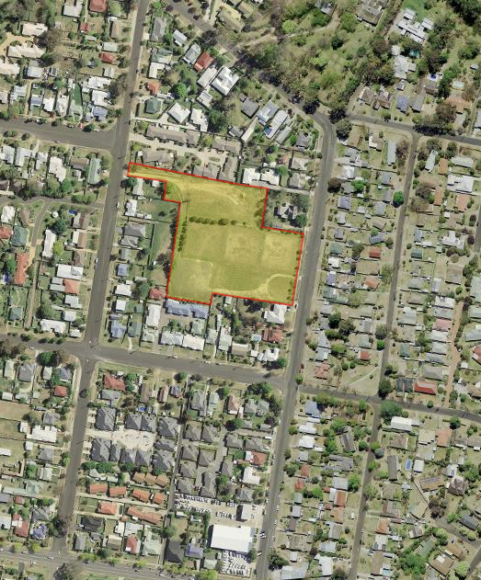
Figure 2: Aerial photograph of subject site (Source: adapted from Six Maps)

A Council development application for 49 dwellings on the subject site has been lodged for assessment and is on public exhibition. The plans utilise an access handle from George Street and another access point off Burrundulla Avenue.
The site plan is detailed over.

Site context and setting
The subject site immediately adjoins land zoned R3 Medium Density Residential. The surrounding development is a mix of one and two storey residential development, with single dwelling houses on single lots interspersed with multi dwelling development.
Immediately to the east, on the western side of Burrundulla Ave, is land zoned R2 Low Density Residential, characterised by one and two storey development and predominately single dwelling development.

Part 2 – Explanation of Provisions
The subject site (Lot 122 DP 1074283) has the following planning controls:
- Land zoning: part R3 Medium Density Residential and part RE2 Private Recreation.
- Height of building: part 8.5m and part no maximum height.
- Minimum lots size: part 600m² and part no minimum lot size.
The planning proposal seeks to amend Mid-Western Regional Local Environmental Plan 2012 by:
- Rezoning part of the subject land from RE2 Private Recreation to R3 Medium Density Residential.
- Amending the Height of Buildings map to make the maximum height of building 8.5m over the entire subject site.
- Amending the Minimum Lot Size map to make the minimum lot size 600m² over the entire subject site.
The development controls for the subject site will mirror the controls of the adjoining land.
The Planning Proposal is a map only amendment. No amendments to the written provisions are proposed.
Figure 3 and Figure 4 below demonstrate the existing and proposed zonings maps (adapted from Mecone Mosaic base mapping).
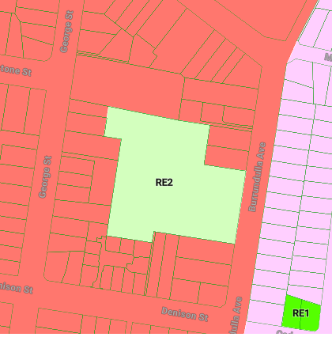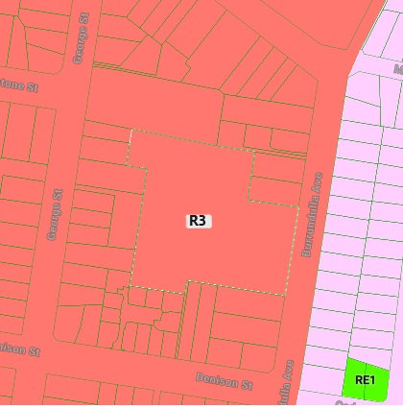
Figure 3: Existing – Land Zoning Map Figure 4: Proposed – Land Zoning Map

Figure 5 and Figure 6 demonstrate the existing and proposed height of building maps (adapted from Mecone Mosaic base mapping).
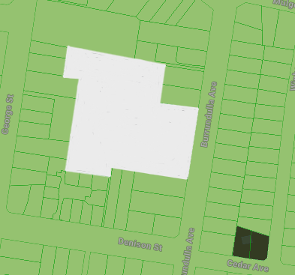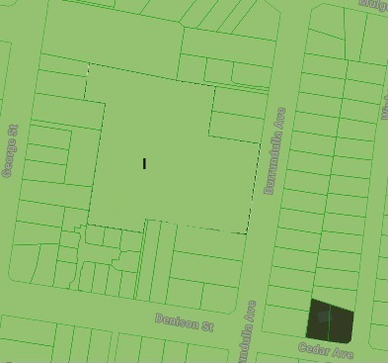
Figure 5: Existing – Height of Building Map Figure 6: Proposed - Height of Building Map

Figure 7 and Figure 8 demonstrates the existing and proposed lot size maps (adapted from Mecone Mosaic base mapping).
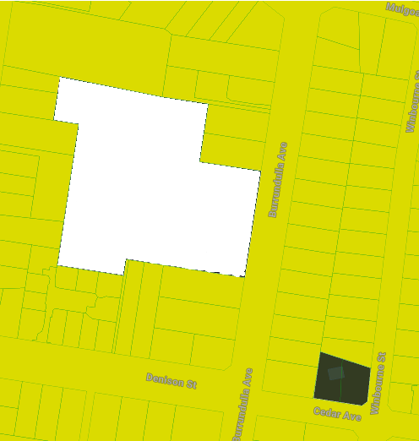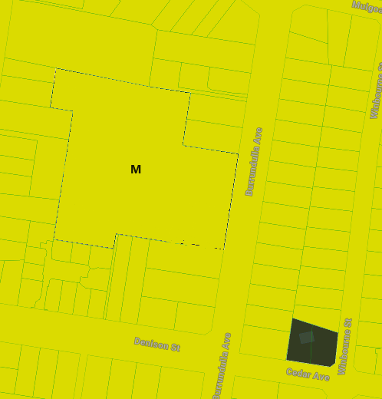
Figure 7: Existing - Minimum Lot Size Figure 8: Proposed - Minimum Lot Size

Part 3 – Justification

Section A - Need for the Planning Proposal

Q1: Is the planning proposal the result of an endorsed LSPS, strategic study or report?
The Planning Proposal is supported by Council’s endorsed Local Strategic Planning Statement (LSPS) and the Mudgee and Gulgong Urban Release Strategy (2023 Updates).
Our Place 2040 – Mid-Western Regional LSPS supports the planning proposal through Planning Priority 2.
Planning Priority 2 Make available diverse, sustainable, adaptable and affordable housing options through effective land use planning.
The planning proposal supports this priority by contributing to housing diversity which in turn, will attract new residents to the Region or ensure existing residents have a choice of housing that suits their needs as their circumstances change.
Our Place 2040 – Mid-Western Regional LSPS can be read at:
https://www.midwestern.nsw.gov.au/files/assets/public/v/1/council/plans-and-strategies/plan-local-strategic-planning-statement-2020.pdf
The Mudgee and Gulgong Urban Release Strategy (2023 Updates) prepared by HillPDA updates the 2014 Strategy of the same name. The purpose of this strategy is to:
▪ Assess the supply and demand of residential land and the status of previously-identified urban release areas (URAs)
▪ Recommend any required changes to facilitate anticipated demand shortfalls
▪ Inform Council’s strategic planning works and servicing, and
▪ Provide a framework for the systematic release of residential land to manage the balance of supply and demand over the study period (2021-2041).
Whilst the Strategy identifies a framework for release of residential land, the Strategy states that Council will need to encourage and enable infill development to ensure that additional pressure is not placed on the land identified in this strategy.
The strategy highlights that utilising Council or government owned land could be an opportunity to increase infill development.

Mudgee and Gulgong Urban Release Strategy (2023 Updates) can be viewed at:
https://www.midwestern.nsw.gov.au/files/assets/public/v/1/council/policies/adopted-mudgee-and-gulgong-urban-release-strategy-2023-update-cm-18.10.2023-min-243-23.pdf

Q2: Is the planning proposal the best means of achieving the objectives or outcomes, or is there a better way?
The Planning Proposal is the best and only means of rezoning the subject site by amending the Land Zoning map within the Mid-Western LEP 2012 and achieve the intended outcomes and objectives of the Planning Proposal.
Further the Height of Building map and Minimum Lot Size map must also be amended to reflect the surrounding development control. This can only be achieved through a planning proposal.

Section B - Relationship to Strategic Framework

Q3: Will the planning proposal give effect to the objectives and actions of the applicable regional or district plan or strategy?
Yes, the Planning Proposal will give effect to the Central West and Orana Regional Plan 2041.
Strategy | direction/action/objective - comment
Central West and Orana Regional Plan 2041 | Objective 13: Provide well located housing options to meet demand.  The Planning Proposal is in a well-located area close to Mudgee CBD and amenities and services.  Strategy 13.1  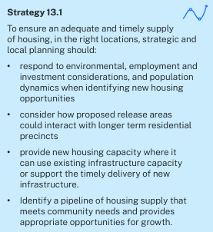  As future housing on the site will be infill development, the development will utilise existing infrastructure capacity. The development will be in the right location and will supply much needed diverse housing type.  Objective 14: Plan for diverse, affordable, resilient and inclusive housing.  The Planning Proposal will rezone the subject site to R3 Medium Density Residential. It is likely that the future development will be in the form of multi-dwelling housing.  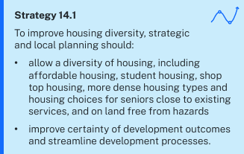  The planning proposal allows a diversity of housing on a large parcel of land free of hazards and constraints. Again, It is well located to existing services and infrastructure and would appeal to downsizes, first home buyers and those residents looking for a low maintenance more affordable dwelling than a single dwelling on a large lot.

Q4: Is the planning proposal consistent with a council LSPS that has been endorsed by the Planning Secretary or GSC, or another endorsed local strategy or strategic plan?
The Planning Proposal is consistent with Council’s Toward’s 2040 and Our Place 2040, Local Strategic Planning Statement. Details on this consistency is detailed in Q1 above.

Q5: Is the planning proposal consistent with any other applicable State and regional studies or strategies?
The Planning Proposal supports the NSW Government’s priority to boost housing supply by creating a housing supply pipeline. The Planning Proposal provides additional housing (up to 49 dwellings) in the form of infill development that is diverse and close to Mudgee CBD capitalising on social and physical infrastructure.
The exact number of dwellings will be determined during the detail design phase and submission of a development application in the future.

Q6: Is the planning proposal consistent with applicable SEPPs?
Yes. An analysis of the applicable State Environmental Planning Policies (SEPP’s) is included in the following table.
SEPP TITLE | PLANNING PROPOSAL CONSISTENCY
SEPP (Biodiversity and Conservation) 2021 | Yes - The Planning Proposal will not impede the ongoing  implementation of the provisions of the SEPP.
SEPP (Sustainable Buildings) 2022 | Yes - The Planning Proposal is consistent with the SEPP and will not impede the ongoing implementation of the provisions of the SEPP.  Future development application would need to address the SEPP.
SEPP (Exempt & Complying Development  Codes) 2008 | Yes - The Planning Proposal is consistent with the SEPP and will not impede the ongoing implementation of the provisions of the SEPP.
SEPP (Housing) 2021 | Yes – The Planning Proposal is consistent with the SEPP and will not impede the ongoing implementation of the provisions of the SEPP
SEPP (Industry and Employment) 2021 | Not applicable.
SEPP No 65 – Design and Quality of  Residential Apartment Development | Not applicable.
SEPP (Planning Systems) 2021 | Yes - The Planning Proposal is consistent with the SEPP and will not impede the ongoing implementation of the provisions of the SEPP.
SEPP (Precincts – Central River City) 2021 | Not applicable.
SEPP (Precincts – Eastern Harbour City)  2021 | Not applicable.
SEPP (Precincts – Regional) 2021 | Yes - The Planning Proposal is consistent with the SEPP and will not impede the ongoing implementation of the provisions of the SEPP.
SEPP (Precincts – Western Parkland City)  2021 | Not applicable.
SEPP (Primary Production) 2021 | Not applicable.
SEPP (Resilience and Hazards) 2021 | Yes - The Planning Proposal is consistent with the SEPP and will not impede the ongoing implementation of the provisions of the SEPP.  Contamination and remediation will be considered at the development application stage.
SEPP (Resources and Energy) 2021 | Yes - The Planning Proposal is consistent with the SEPP and will not impede the ongoing implementation of the provisions of the SEPP.
SEPP (Transport and Infrastructure) 2021 | Yes - The Planning Proposal is consistent with the SEPP and will not impede the ongoing implementation of the provisions of the SEPP.

Q7: Is the planning proposal consistent with applicable Ministerial Directions (section 9.1 Directions)?
These directions apply to planning proposals lodged with the Department on or after the date the particular direction was issued and commenced.
Detailed in the table below are the directions issued by the Minister for Planning to relevant planning authorities under section 9.1(2) of the Environmental Planning and Assessment Act 1979.
DIRECTION | PLANNING PROPOSAL CONSISTENCY
Focus area 1: Planning Systems
1.1 – Implementation of Regional Plan | Consistent with Regional Plan as detailed in Question 3 above
1.2 - Development of Aboriginal Land Council land | Not applicable
1.3 - Approval and Referral Requirements | The proposed amendments do not include the  requirements for approvals or referrals
1.4 - Site Specific Provisions | Not applicable, as the proposed amendments  are not site specific
1.4A – Exclusion of Development Standards from Variation | Consistent. The Planning Proposal does not limit the application of clause 4.6
1.5 - Parramatta Road Corridor Urban Transformation  Strategy | Not applicable
1.6 - Implementation of North West Priority Growth  Area Land Use and Infrastructure Implementation Plan | Not applicable
1.7 - Implementation of Greater Parramatta Priority Growth Area Interim Land Use and Infrastructure  Implementation Plan | Not applicable
1.8 - Implementation of Wilton Priority Growth Area  Interim Land Use and Infrastructure Implementation Plan | Not applicable
1.9 - Implementation of Glenfield to Macarthur Urban  Renewal Corridor | Not applicable
1.10 - Implementation of the Western Sydney  Aerotropolis Plan | Not applicable
1.11 - Implementation of Bayside West Precincts 2036  Plan | Not applicable
1.12 - Implementation of Planning Principles for the  Cooks Cove Precinct | Not applicable
1.13 - Implementation of St Leonards and Crows Nest  2036 Plan | Not applicable
1.14 - Implementation of Greater Macarthur 2040 | Not applicable
1.15 - Implementation of the Pyrmont Peninsula Place  Strategy | Not applicable
1.16 - North West Rail Link Corridor Strategy | Not applicable
1.17 - Implementation of the Bays West Place Strategy | Not applicable
1.18 – Implementation of the Macquarie Park Innovation Precinct | Not applicable
1.19 – Implementation of Westmead Place Strategy | Not applicable
1.20 – Implementation of Camellia-Rosehill Place Strategy | Not applicable
1.21 – Implementation of South West Growth Area Structure Plan | Not applicable
1.22 - Implementation of Cherrybrook Station Place Strategy | Not applicable
Focus area 2: Design and Place
-
Focus area 3: Biodiversity and Conservation
3.1 - Conservation Zones | Consistent
3.2 - Heritage Conservation | Consistent
3.3 - Sydney Drinking Water Catchments | Not applicable
3.4 - Application of C2 and C3 Zones and  Environmental Overlays in Far North Coast LEPs | Not applicable
3.5 - Recreation Vehicle Areas | Not applicable
3.6 - Strategic Conservation Planning | Not applicable
3.7 – Public Bushland | Not applicable
3.8 – Willandra Lakes Region | Not applicable
3.9 – Sydney Harbour Foreshore and Waterways | Not applicable
3.10 – Water Catchment Protection | Not applicable
Focus area 4: Resilience and Hazards
4.1 - Flooding | Consistent
4.2 - Coastal Management | Not applicable
4.3 - Planning for Bushfire Protection | Consistent
4.4 - Remediation of Contaminated Land | Consistent
4.5 - Acid Sulfate Soils | Consistent
4.6 - Mine Subsidence and Unstable Land | Consistent
Focus area 5: Transport and Infrastructure
5.1 - Integrating Land Use and Transport | Not applicable
5.2 - Reserving Land for Public Purposes | Not applicable
5.3 - Development Near Regulated Airports and  Defence Airfields | Not applicable
5.4 - Shooting Ranges | Not applicable
Focus area 6: Housing
6.1 - Residential Zones | Consistent – the Planning Proposal broadens the choice for housing and makes efficient use of existing infrastructure and services
6.2 - Caravan Parks and Manufactured Home Estates | Not applicable
Focus area 7: Industry and Employment
7.1 - Business and Industrial Zones | Not applicable
7.2 - Reduction in non-hosted short-term rental  accommodation period | Not applicable.
7.3 - Commercial and Retail Development along the  Pacific Highway, North Coast | Not applicable.
Focus area 8: Resources and Energy
8.1 - Mining, Petroleum Production and Extractive  Industries | Not applicable
Focus area 9: Primary Production
9.1 - Rural Zones | Not applicable
9.2 - Rural Lands | Not applicable
9.3 - Oyster Aquaculture | Not applicable.
9.4 - Farmland of State and Regional Significance on  the NSW Far North Coast | Not applicable

Section C - Environmental, Social and Economic Impact

Q8: Is there any likelihood that critical habitat or threatened species, populations or ecological communities, or their habitats, will be adversely affected as a result of the proposal?

The subject site is generally cleared of vegetation, with general regrowth on the former bowling greens. The site is overgrown and there is a stand of trees on site.

It is highly unlikely that there will be any direct adverse impacts on critical habitat or threatened species, populations or ecological communities, or their habitats. Site specific constraints will be considered during the assessment of any future development applications within the subject area.

Q9: Are there any other likely environmental effects as a result of the planning proposal and how are they proposed to be managed?
As set out in Department’s Local Environmental Plan Making Guideline (August 2023), the purpose of this question is to ascertain the likely environmental effects that may be relevant. The nature of the planning proposal is such that no technical information is required.

Q10: How has the planning proposal adequately addressed any social and economic effects?
The social and economic effects of the planning proposal are positive for Mid-Western LGA and the local and future residents. The planning proposal will facilitate future development of multi dwelling housing that will contribute to the housing diversity and choice in Mudgee.
The site is close to the Mudgee town centre, being the largest town in Mid-Western LGA enjoying high amenities and services including schools, childcare, medical facilities and retail and commercial services.
Positive economic effect with an increase in jobs during construction and future residents will be close to jobs in Mid-Western’s largest and main township.

Q11: Is there adequate public infrastructure for the planning proposal?
The site will capitalise on existing infrastructure and services – water, sewer, electricity, phone and NBN.

Q12: What are the views of state and federal public authorities and government agencies consulted in order to inform the Gateway determination?
The views of state and federal public authorities and government agencies were not sort prior to Gateway determination due to the nature of the Planning Proposal.

Part 4 – Mapping
The Planning Proposal is a map only amendment. Maps submitted to the Department post Gateway determination will be consistent with the Department’s Standard Technical Requirements for Spatial Datasets and Maps.
The following maps will be subject to amendments:
- 5270_COM_LZN_006G_010_20230317
- 5270_COM_HOB_006G_010_20120619
- 5270_COM_LSZ_006G_010_20230317

Part 5 – Community Consultation
Community consultation has not been carried out prior to the preparation of the Planning Proposal.
The Planning Proposal is considered ‘standard’ in accordance with the Department’s Local Environmental Plan Making Guideline (August 2023) and requires a public exhibition period of 20 days.
Public exhibition will be undertaken in accordance with any issued Gateway Determination and Council policy.

Part 6 – Project Timeline
The Planning Proposal is a minor amendment to the Mid-Western Local Environmental Plan 2012 and should be able to be achieved within 6-9 months of the date of the Gateway Determination.

Proposed Timeline
Milestone | Date
Gateway Determination | April 2024
Completion of Technical Information | N/A
Agency Consultation | May 2024
Public Exhibition | June 2024
Consideration of Submissions | August 2024
Report to Council | September 2024
Legal Drafting & Opinion (incl Mapping) | September 2024
Finalisation | October 2024

